EXPERIMENT 3
STEPPER MOTOR USING AT89C51 USING PROTEUS
AIM: To write an assembly language program for Stepper Motor using AT89C51 using Keil and Proteus.
SOFTWARE REQUIRED: Proteus 8 software
ALGORITHM
- Load the first step pattern 09H on Port 2.
- Apply a delay.
- Load 0CH, 06H and 03H successively with delays.
- Repeat the sequence continuously to rotate the stepper motor.
PROGRAM
ORG 0000H
UP: MOV P2,#09H
ACALL DELAY
MOV P2,#0CH
ACALL DELAY
MOV P2,#06H
ACALL DELAY
MOV P2,#03H
ACALL DELAY
SJMP UP
DELAY: MOV R4,#18
H1: MOV R3,#255
H2: DJNZ R3,H2
DJNZ R4,H1
RET
END
OUTPUT IMAGE

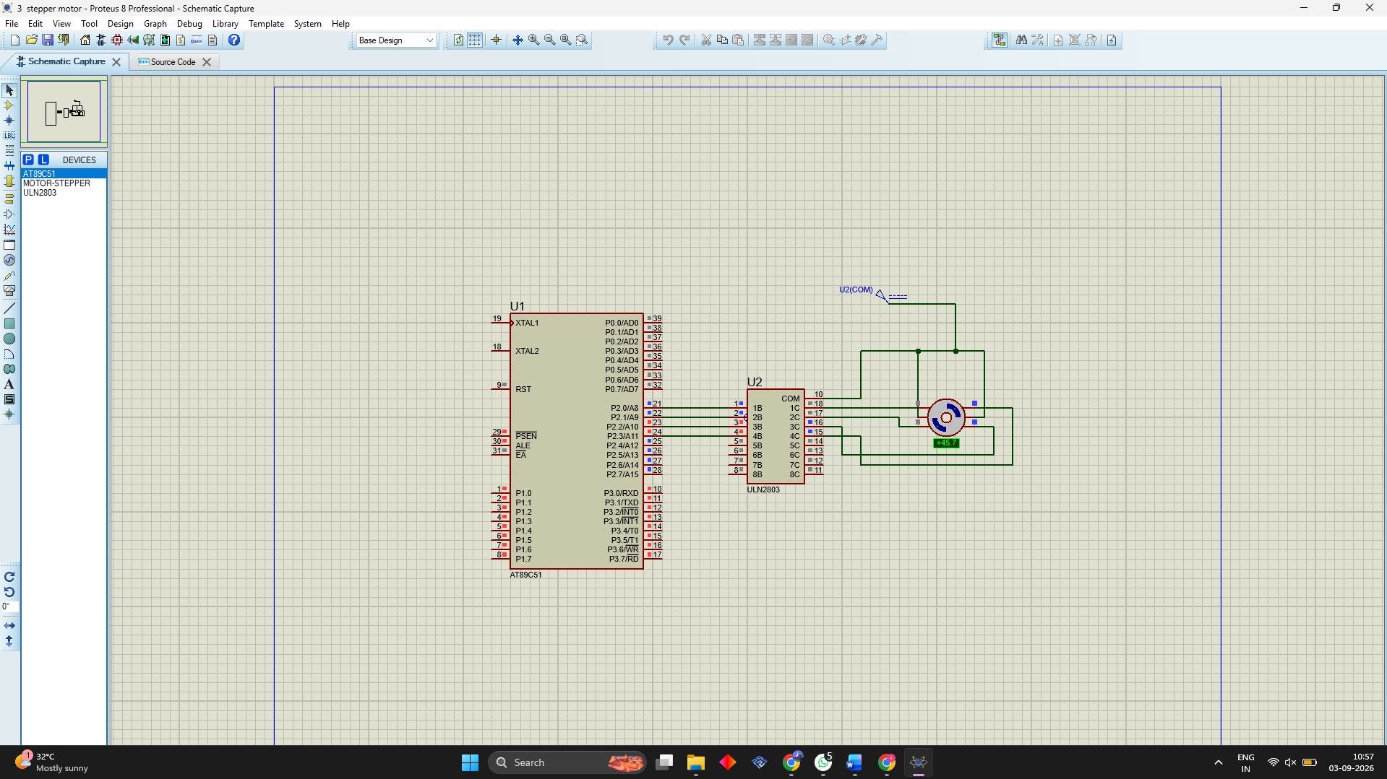

RESULT
Thus the program has been successfully verified and executed.

